Don’t Try to Barnstorm Proof of Printed Publication
By H. Wayne Porter

October 16, 2014 — The PTAB recently denied institution of inter partes review based on a petitioner’s failure to prove that a document was indeed a printed publication qualifying as prior art to the patent at issue.

IPR2014-00671 – A.R.M., Inc. v. Cottingham Agencies Ltd. (Paper 10)

The patent in question is titled “Amusement Ride.” In a decision entered October 3, 2014, the PTAB denied a petition to institute inter partes review. The decision is notable for two things. First, the decision includes an impressive drawing depicting an embodiment of a ride which, as summarized by the PTAB, involves “conveyance of riders through the air in a manner simulating flight at an elevation sufficiently high to produce a thrilling sensation”:
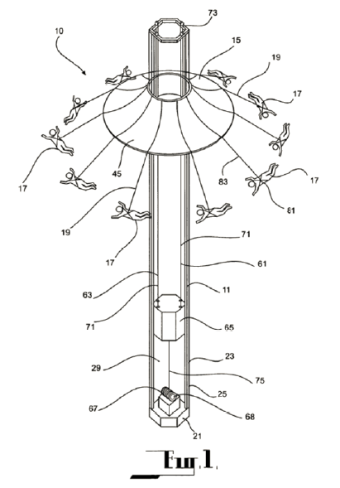

Second, the decision denied institution of trial because the petitioner failed to prove that a document qualified as prior art to the patent at issue. The petitioner challenged claims of the patent as obvious over various combinations of references that included a one-page, undated document depicting a ride known as the “Barnstormer.” The petitioner also submitted a declaration and argued that the declaration dated the Barnstormer document before the filing date of the patent at issue.

The PTAB noted that, in fact, the declaration did not identify any date for the Barnstormer document, and that no date appeared on the face of the document. The PTAB also noted that the petitioner provided virtually no argument or evidence in support of a conclusion that the Barnstormer document was a printed publication available as prior art to the patent at issue.

As indicated by the PTAB, the key inquiry was whether the Barnstormer document was made “sufficiently accessible to the public interested in the art” before the relevant date, and that “[a] given reference is ‘publicly accessible’ upon a satisfactory showing that such document has been disseminated or otherwise made available to the extent that persons interested and ordinarily skilled in the subject matter or art exercising reasonable diligence, can locate it.” Although the PTAB acknowledged that the petitioner provided evidence that the Barnstormer ride was operated and available to the public before the relevant date, the PTAB found that the petitioner offered no evidence of a date when the Barnstormer document was a publication, and no evidence that the Barnstormer document was disseminated or otherwise made available such that relevant persons could locate it.

This decision highlights the importance of a petitioner satisfying its burden to prove a non-patent document is, in fact, a printed publication under 35 U.S.C. § 102. The decision also highlights one of the limitations of the inter partes review procedure. In particular, an inter partes review can only be instituted on the basis of prior art consisting of patents or printed publications. Other types of prior art such as prior public use is not enough. As can be seen by comparing an image from the Barnstormer document (below left), and an image from the declaration submitted by the petitioner (below right),

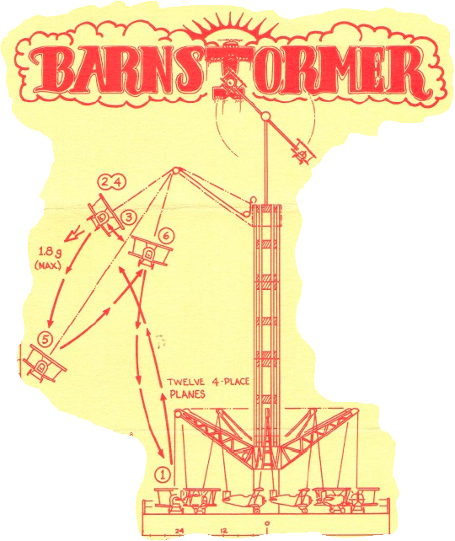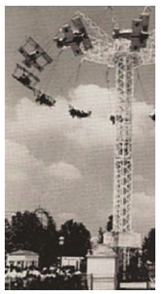

the public use prior art and the Barnstormer document appear to show the same thing, yet the Barnstormer document failed to constitute a printed publication, so the petition to institute an inter partes review trial was denied.

The Leahy-Smith America Invents Act established new patent post-issuance proceedings, including the inter partes review, post grant review and transitional program for covered business method patents, that offer a less costly, streamlined alternative to district court litigation. With the U.S. Patent and Trademark Office’s Patent Trial and Appeal Board conducting a large and increasing number of these proceedings, and with the law developing rapidly, Banner & Witcoff will offer weekly summaries of the board’s significant decisions and subsequent appeals at the U.S. Court of Appeals for the Federal Circuit.

www.bannerwitcoff.com

© Copyright 2014 Banner & Witcoff, Ltd. All Rights Reserved. The opinions expressed in this publication are for the purpose of fostering productive discussions of legal issues and do not constitute the rendering of legal counseling or other professional services. No attorney-client relationship is created, nor is there any offer to provide legal services, by the publication and distribution of this edition of PTAB Highlights.

